OptoFidelity Two-Finger

User Manual

**Version 1.4**

Contents

1 Introduction 3

2 Safety precautions 3

3 Connections and status LEDs 4

3.1 Finger and PTB Box signals 4

3.2 Power input 6

3.1 Ethernet 6

3.2 Two-finger control 7

3.1 Status LEDs 7

3.1 Robot control 7

4 Two-finger installation and connection 8

5 Actuator maintenance 10

5.1 Finger switch 10

5.2 Finger tips 10

5.3 Motors and belt 10

5.4 Linear guide and ball screw 11

5.5 Finger bearings 12

6 Change history 13

# Introduction

This document is user guide for the two-finger actuator. This document needs to be read through before operating device. Ethernet communication is described in a separate communication specification document.

# Safety precautions

The Two-Finger actuator has the safety functions to comply with the following safety regulations:

European standard: SFS-EN 61326, EN ISO 10218-1

Operating or maintaining the actuator without regard to the safety guidelines may damage the machine or cause injuries. Always read the safety precautions carefully.

* Be careful and don’t let your hands get pinched by the movable parts.
* Precautions during operation, movement, maintenance and inspection: make sure that two-finger controller is powered off during maintenance.
* Be careful with sharp parts of the two-finger actuator. Do not put fingers near rotation axel. See the image below.

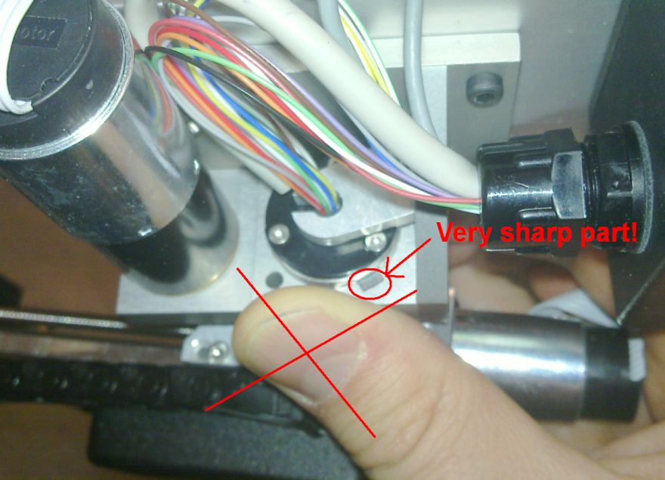

Figure 1: Rotation axel of two-finger actuator

* To maintain safety do not make any modifications to the equipment in order.
* Use only power supply what is delivered for two-finger controller.
* Avoid installing places which receive direct sunlight or where temperature exceeds range 0˚C - 40 ˚C

# Connections and status LEDs

The next picture shows two-finger controller connections and status LEDs.

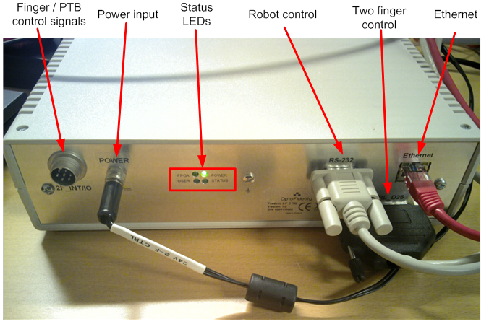

Figure 2: two-finger controller connections and status LEDs

## Finger and PTB Box signals

2F_INT/IO_PTB connector outputs signals from fingers. This can be connected to the interrupt input of the OF-PIT box and control input of PTB box. Due to mechanical tolerance, triggering of the fingers is not ideally simultaneous. When the finger is in the bottom position the output level is 0 V. When the finger is above the bottom position (connection is open in finger) the output level is about 4,5 V. Cable is included in the two-finger delivery.

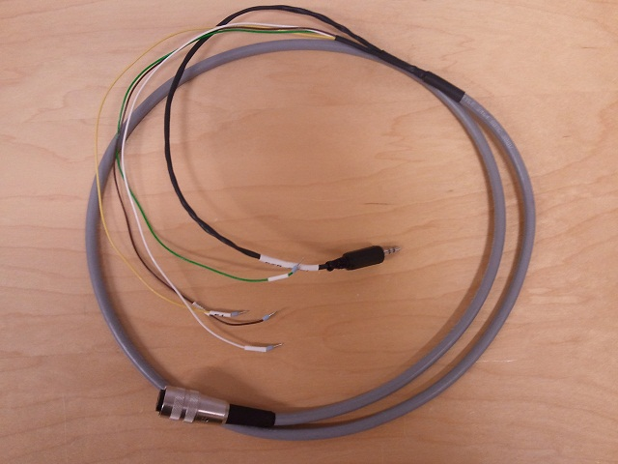

Figure 3: Cable

PTB box is used to control the initialization sequence of Janome Cast Pro III robot. The operation port of robot is connected to the input port of PTB box by a D15 cable. The emergency stop unit of the robot is connected to the output port of PTB box. PTB control wire from 2F_INT/IO_PTB connector is connected to the control input of PTB box.



Figure 4: PTB box

PTB box enables the robot initialization sequence as follows. When powering on the robot, the two-finger actuator needs to be rotated into home position. After this, a green light in the button of the emergency stop starts to flash. By pushing the button, the robot executes home run and after this it is ready to be used with the two-finger actuator.

## Power input

Controller uses power supply that outputs 24 V and 1.6 A. The power supply is included in the two-finger delivery.

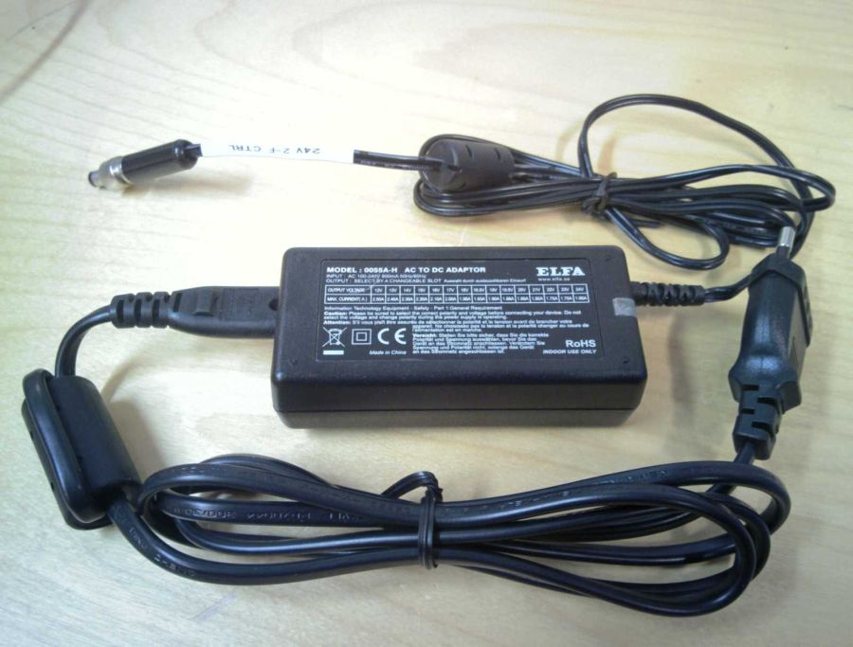

Figure 5: Power supply

## Ethernet

Ethernet connection is used between two-finger controller and PC. A crossed Ethernet cable is provided with the tester so controller can be connected directly to the PC. Controller uses static IP address 10.10.12.2. IP address of the PC can be for example 10.10.12.1.

## Two-finger control

Two-finger actuator is connected to the controller using a D-25 female-female cable. Cable length is 4 m.

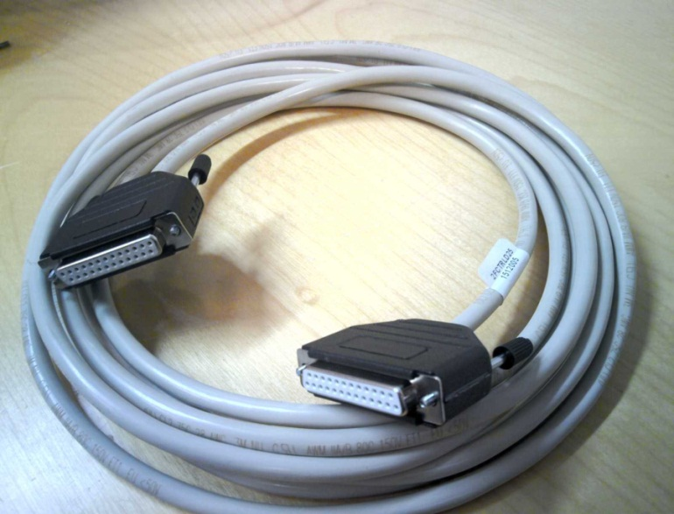

Figure 6: D-25 female-female cable

## Status LEDs

|  |  |
| --- | --- |
| **LED** | **Description** |
| POWER | Indicates that power is on. |
| FPGA | Blinks when FPGA is running. System is functional only if this led is blinking. |
| STATUS | This is on when the device boots. Should be off when the device is ready for action. |
| USER | Indicates that TCP connection is open. |

## Robot control

Controller box has a RS232 serial connector for the Janome robot control. Use D9 male-female cable between robot and controller. D9 cable is not included in the two-finger delivery.

# Two-finger installation and connection

Two-finger actuator is installed to the Janome robot arm with four screws. Use 4 mm hex key for screws. OptoFidelity has delivered Janome robots with two different z-axel energy chain attachments. You may need to remove the energy chain support if the two-finger actuator doesn’t fit to the robot arm. The energy chain can be attached to the two-finger actuator in this case. See Figure 7 and Figure 8.

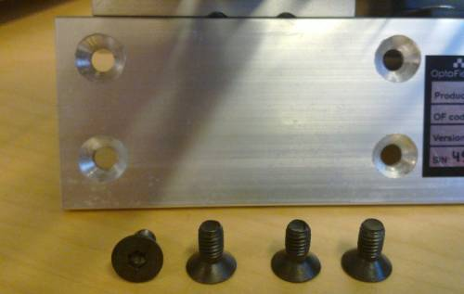

Figure 7: Screws for installing two-finger actuator

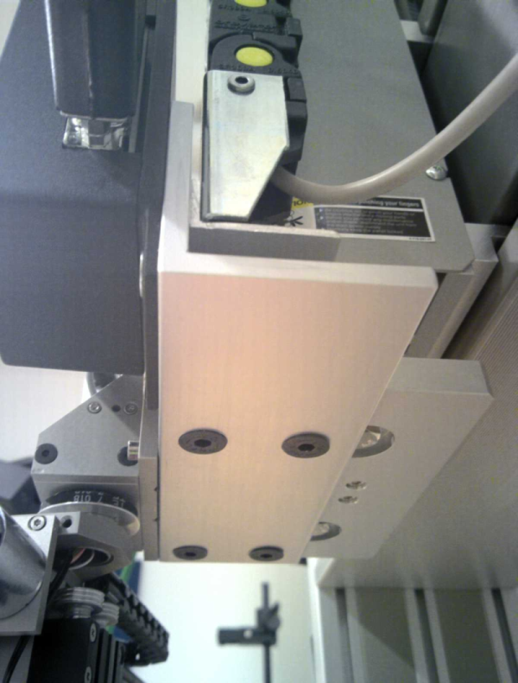

Figure 8: Two-finger installation

Connect 25-pin d-connector to the two-finger actuator.

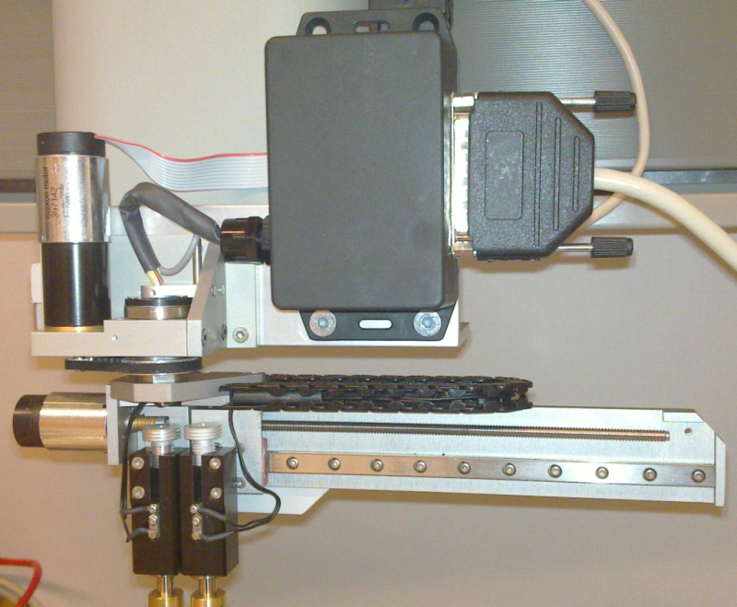

Figure 9: Connecting 25-pin d-connector

# Actuator maintenance

These maintenance instructions expect that two-finger actuator is used in a normal office environment. Actuator is not designed to work in very unclean or dusty environments. Use appropriate lubricates for different locations. Mixing with other types might cause malfunction or performance decrease. All maintenance operations should be done by person who has good knowledge about fine mechanic devices. It is recommended that two-finger actuator is delivered to OptoFidelity for maintenance. Maintenance requirements are summarized in the following table.

|  |  |  |  |
| --- | --- | --- | --- |
|  | **Maintenance requirement** | | |
| **Part name** | **Once per week** | **Once per month** | **Once per year** |
| **Finger switch** | M |  |  |
| **Finger tips** | M |  |  |
| **Motors and belt** |  | C |  |
| **Linear guide and ball screw** |  | M |  |
| **Finger bearings** |  | M |  |

*M = Carry out maintenance action*

*C = Check condition*

## Finger switch

Oxidation of finger switch connectors decreases the electrical conductivity. Clean switch contactors with appropriate alcohol one per week.

## Finger tips

Clean finger tips with clean fabric once per week.

## Motors and belt

Motors or the drive belt of the actuator normally don’t need any maintenance. The belt can be replaced if there are signs of detrition. Belt type is: Bando 44MXL, width 3,2mm, Ammeraal Beltech

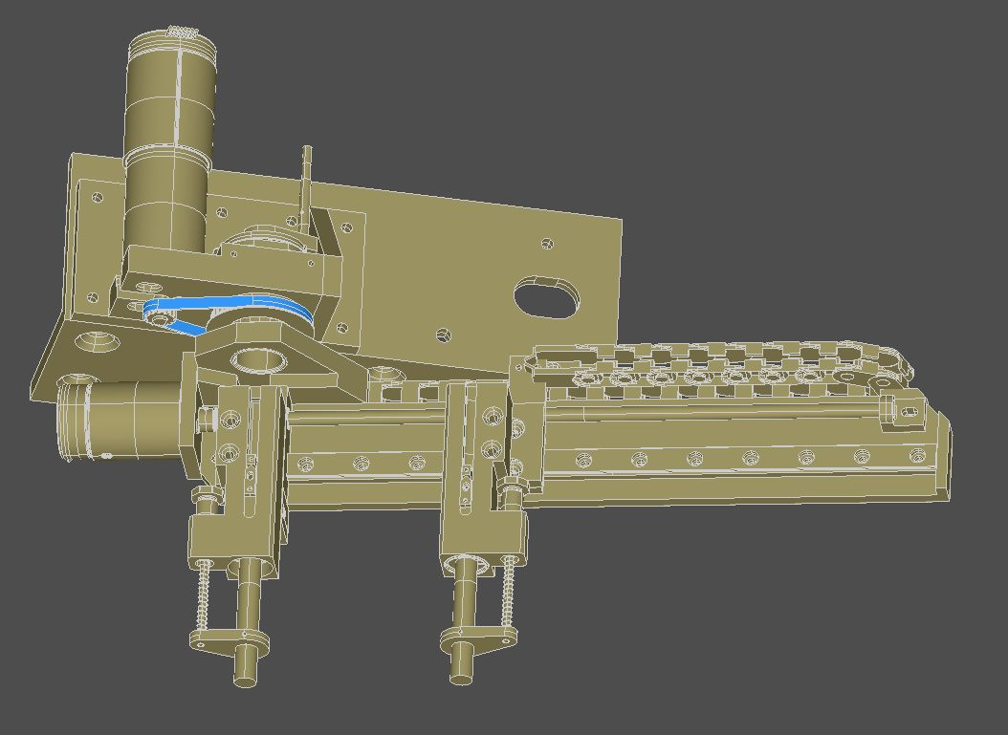

Figure 10: Belt drive

## Linear guide and ball screw

The linear guide needs to be cleaned periodically using a soft cloth. The linear guide should be lubricated between 100 km movement. Use lubricate that has viscosity 32-100 cSt.

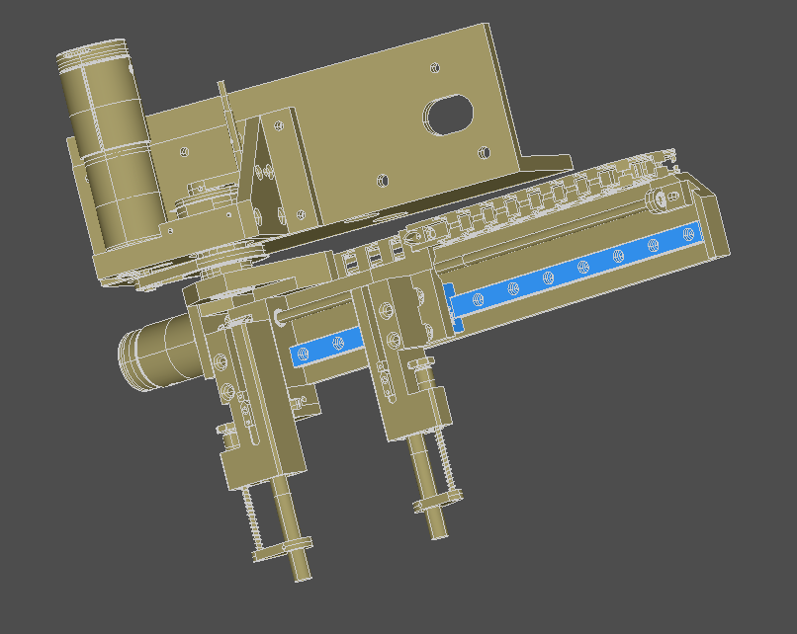

Figure 11: Linear guide

The ball screw should be lubricated using Microlube GBU 131 or similar that has 130 cSt viscosity.

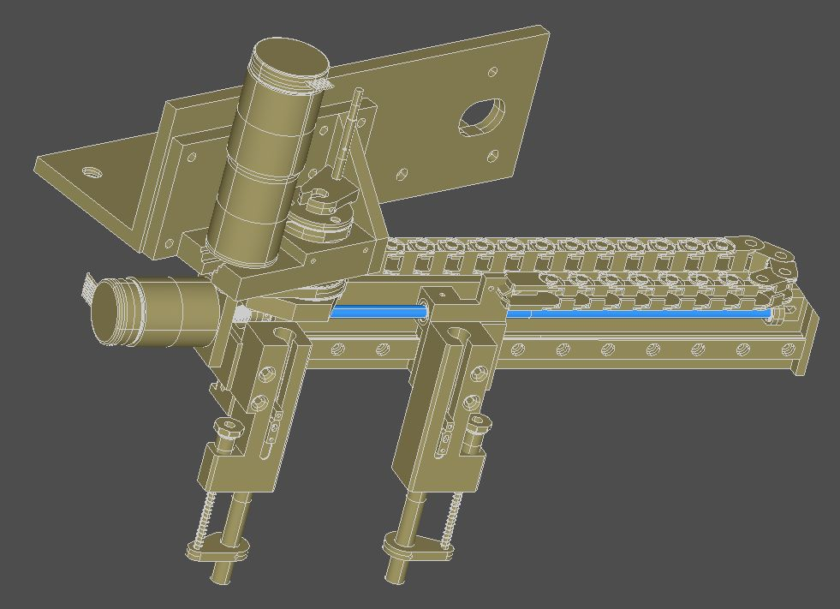

Figure 12: Ball screw

## Finger bearings

Finger bearings can be lubricated using e.g. Wurth HHS5000.

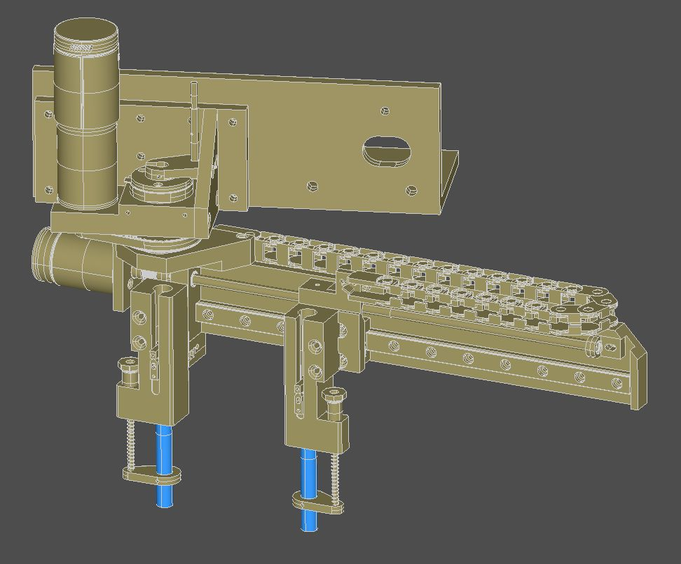

Figure 13: Finger bearings

# Change history

|  |  |  |  |  |
| --- | --- | --- | --- | --- |
| Ver. | Status | Date | Author | Remarks |
| 0.1 | draft | 24.02.2011 | MJU | First version |
| 1.0 | final | 08.03.2011 | VHE | Checked by VHE |
| 1.1 | final | 04.11.2011 | VHE | Added PTB box |
| 1.2 | final | 06.03.2012 | MJU | Added safety and maintenance instructions |
| 1.3 | final | 22.03.2012 | MJU | New document template. Added pictures to maintenance section. |
| 1.4 | final | 24.04.2013 | VHE | Minor updates, maintenance requirement table added. |
|  |  |  |  |  |
|  |  |  |  |  |